Základní škola Olomouc

příspěvková organizace

Mozartova 48, 779 00 Olomouc

tel.: 585 427 142, 775 116 442; fax: 585 422 713

e-mail: kundrum@centrum.cz; www.zs-mozartova.cz

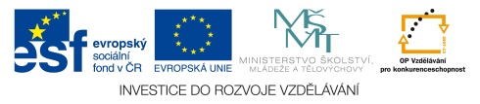

Projekt: ŠKOLA RADOSTI, ŠKOLA KVALITY
Registrační číslo projektu: CZ.1.07/1.4.00/21.3688

EU PENÍZE ŠKOLÁM
Operační program Vzdělávání pro konkurenceschopnost

Autor: | Mgr. Pavla Repová
Vzdělávací oblast: | Jazyk a jazyková komunikace
Vzdělávací obor: | Anglický jazyk
Vyučovací předmět: | Anglický jazyk
Ročník: | 5.
Tematická oblast: | Konverzační témata
Téma hodiny: | School systems 2
Označení DUM: | VY_32_INOVACE_42.06.REP.AJ.5
Vytvořeno: | 20. 02. 2014

Popiš obrázky a rozhodni, zda se jedná o výukový předmět či kroužek.
PICTURE | ENGLISH NAME | SCHOOL SUBJECT/ CLUB | PICTURE | ENGLISH NAME | SCHOOL SUBJECT/  CLUB
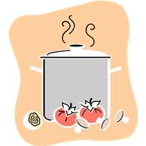  1 | Cooking | Club |   4
  2 |  |  | 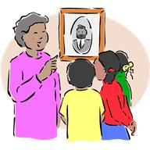  5
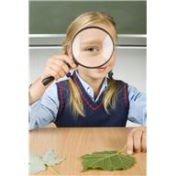  3 |  |  |   6

Spoj obrázky výukových předmětů a kroužků s jejich anglickými názvy.
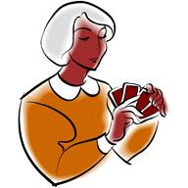
Geography
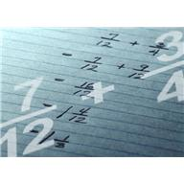
Music


ICT

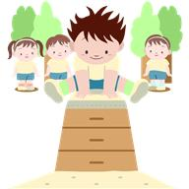
Card games

Maths

PE


Homework

Prohlédni si Tomův rozvrh. Doplň otázky a odpověz na ně.
 | Monday | Tuesday | Wednesday | Thursday | Friday
8.30-9.00 | REGISTRATION | AND | ASSEMBLY
9.00-10.00 | English | Citizenship | English | PE | Maths
10.05-11.05 | English | Maths | Science | English | Maths
11.05-11.20 | RE | English | Science | Science | History
11.20-12.20 | PE | Music | Technology | Science | History
12.20-1.20 | L | U | N | C | H
1.20-2.20 | Art and Design | French | Geography | Maths | Games
2.25-3.25 | ICT | French | Geography | Maths | Games

Christine 1 When have you got a double period of English?
Tom 2 I´ve got double English on Monday.
Christine 3 ________________________ Citizenship?
Tom 4 __________________________________.
Christine 5 ________________________ Art and Design?
Tom 6 __________________________________.
Christine 7 _______________________ a double period of Games?
Tom 8 __________________________________.
Christine 9 __________________________________ PE?
Tom 10 __________________________________.

Odpověz na otázky. Použij řadové číslovky.
1. When have you got RE on Monday? First and second lesson.
2. When have you got Music on Tuesday? _______________________.
3. When have you got English on Wednesday? _______________________.
4. When have you got Science on Thursday? _______________________.
5. When have you got Games on Friday? _______________________.
Přečti si text a zakroužkuj správné odpovědi.

Hello, my name´s Alice. I´m ten and I´m in year five. My school is called Highlands Junior school.
It is a state school – education is for free.
There are 28 students in my class. We wear a school uniform, that is a white shirt, blue pullover and a jacket, grey trousers or a skirt and dark shoes.
In school we learn subjects like English, Maths, Science, ICT, RE, Design and Technology, History, Geography, Art, Music and PE. My favourite subjects are English and Music. This term we have got English every day and a double period of Music on Friday. Hooray!
Around noon there is a lunch break. We eat at the canteen or we bring our packed lunches from home. In the afternoon some students go to school clubs. I have got computers on Tuesday and extra French on Thursday.
I like my school.

1. Alice is in year ten. TRUE FALSE
2. Highlands Junior is a private school. TRUE FALSE
3. All children have got the same clothes for school. TRUE FALSE
4. Alice likes English and Music. TRUE FALSE
5. This term Alice has got Music every day. TRUE FALSE
6. All children eat canteen´s food. TRUE FALSE
7. Alice goes to school clubs in the mornings. TRUE FALSE

Odpověz na otázky.

1. What year are you in? ______________________________.
2. Have you got a school uniform on? ______________________________.
3. What are your favourite subjects? ______________________________.
4. Is there a packed lunch in your bag? ______________________________.
Popiš obrázky a rozhodni, zda se jedná o školní předmět či kroužek.
PICTURE | ENGLISH NAME | SCHOOL SUBJECT/ CLUB | PICTURE | ENGLISH NAME | SCHOOL SUBJECT/  CLUB
1 | Cooking | Club | 4 | Sewing | Club
2 | English | Subject | 5 | History | Subject
3 | Science | Subject | 6 | Choir | Club

Spoj obrázky školních předmětů a kroužků s jejich anglickými názvy.
Geography
Music

ICT

Card games

Maths
PE
Homework

Prohlédni si Tomův rozvrh. Doplň otázky a odpověz na ně.
 | Monday | Tuesday | Wednesday | Thursday | Friday
8.30-9.00 | REGISTRATION | AND | ASSEMBLY
9.00-10.00 | English | Citizenship | English | PE | Maths
10.05-11.05 | English | Maths | Science | English | Maths
11.05-11.20 | RE | English | Science | Science | History
11.20-12.20 | PE | Music | Technology | Science | History
12.20-1.20 | L | U | N | C | H
1.20-2.20 | Art and Design | French | Geography | Maths | Games
2.25-3.25 | ICT | French | Geography | Maths | Games

Christine 1 When have you got a double period of English?
Tom 2 I´ve got double English on Monday.
Christine 3 When have you got Citizenship?
Tom 4 I´ve got Citizenship on Tuesday.
Christine 5 When have you got Art and Design?
Tom 6 I´ve got Art and Design on Monday.
Christine 7 When have you got a double period of Games?
Tom 8 I´ve got double Games on Friday.
Christine 9 When have you got PE?
Tom 10 I´ve got PE on Monday and Thursday.

Odpověz na otázky. Použij řadové číslovky.
1. When have you got RE on Monday? First and second lesson.
2. When have you got Music on Tuesday? Fourth lesson.
3. When have you got English on Wednesday? First lesson.
4. When have you got Science on Thursday? Third and fourth lesson.
5. When have you got Games on Friday? Fifth and sixth lesson.
Přečti si text a zakroužkuj správné odpovědi.

Hello, my name´s Alice. I´m ten and I´m in year five. My school is called Woodlands Junior school.
It is a state school – education is for free.
There are 28 students in my class. We wear a school uniform, that is a white shirt, blue pullover and a jacket, grey trousers or skirt and dark shoes.
In school we learn subjects like English, Maths, Science, ICT, RE, Design and Technology, History, Geography, Art, Music and PE. My favourite subjects are English and Music. This term we have got English every day and a double period of Music on Friday. Hooray!
Around noon there is a lunch break. We eat at the canteen or we bring our packed lunches from home. In the afternoon some students go to school clubs. I have got computers on Tuesday and extra French on Thursday.
I like my school.

1. Alice is in year ten. TRUE FALSE
2. Woodlands Junior is a private school. TRUE FALSE
3. All children have got the same clothes for school. TRUE FALSE
4. Alice likes English and Music. TRUE FALSE
5. This term Alice has got Music every day. TRUE FALSE
6. All children eat canteen´s food. TRUE FALSE
7. Alice goes to school clubs in the mornings. TRUE FALSE

Odpověz na otázky.

1. What year are you in? např. I´m in year five.
2. Have you got a school uniform on? No, I haven´t.
3. What are your favourite subjects? např. I like Maths and PE.
4. Is there a packed lunch in your bag? Yes, there is. / No, there isn´t.

Základní škola Olomouc

příspěvková organizace

Mozartova 48, 779 00 Olomouc

tel.: 585 427 142, 775 116 442; fax: 585 422 713

e-mail: kundrum@centrum.cz; www.zs-mozartova.cz

Seznam použité literatury a pramenů:
HUTCHINSON, T. Project učebnice angličtiny 1. Oxford : Oxford University Press, 2008. ISBN 978-0-19-476414-8. s. 28-30.

Použité zdroje:
Obrazový materiál je použit z galerie obrázků a klipartů Microsoft Office.

