Základní škola Olomouc

příspěvková organizace

Mozartova 48, 779 00 Olomouc

tel.: 585 427 142, 775 116 442; fax: 585 422 713

e-mail: kundrum@centrum.cz; www.zs-mozartova.cz

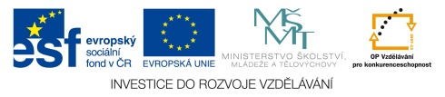

Projekt: ŠKOLA RADOSTI, ŠKOLA KVALITY
Registrační číslo projektu: CZ.1.07/1.4.00/21.3688

EU PENÍZE ŠKOLÁM
Operační program Vzdělávání pro konkurenceschopnost

Autor: | Mgr. Petra Doskočilová
Vzdělávací oblast: | Jazyk a jazyková komunikace
Vzdělávací obor: | Anglický jazyk
Vzdělávací předmět: | Anglický jazyk
Ročník: | 6.
Tematická oblast: | Gramatické jevy
Téma hodiny: | Countable and uncountable words 3
Označení DUM: | VY_32_INOVACE_24.17.DOS.AJ.6
Vytvořeno: | 29. 04. 2014

Countable and uncountable words
1. Read the text, find the COUNTABLE words (red circle) and UNCOUNTABLE words (blue circle). Concentrate on food and drinks.
James plays in American football team. Every day James has three very big meals. For breakfast he has orange juice, cereals, yoghurt, fruit, bread and butter, milk, eggs, bacon, and cake.
A typical lunch is spaghetti, fish, meat, vegetables, and apple pie with cream.
In the evening he has his main meal. Tomato soup, spaghetti, pork and beef, jacket potatoes, chicken salad, rice with mushrooms, and two or three desserts, including his favourite chocolate cake.
2. Work with the text. Find the words in the text and write them to the pictures.
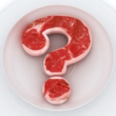 _____________________________
___________________ 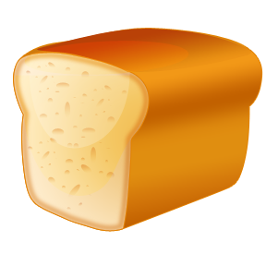 ________________
__________________  _________________
____________________________________

3. Put A/AN or SOME.
a/ For this recipe you need ________rice, _______ egg, _______butter.
b/ I need _______ paper and ______ pen.
c/ I´ve won ________ money in the lottery.
d/ I´m making pizza, so I need _______ cheese and _______ ham.
e/ You´ll need ________ toothbrush, ________ toothpaste and ______ shampoo.
4. Write SOME or ANY.
a/ Jane hasn´t got _______ money.
b/ She needs ________ new shoes.
c/ Have we got _______ food for the party?
d/ I bought _______ presents.
e/ Do you want ______thing to eat?

5. Write A FEW or A LITTLE.
For this recipe you need ____________ onions, ____________ meat, ___________ potatoes, ___________ tomatoes, ___________ beans, ____________ oil and ___________ salt and pepper.

6. Write what is in the picture.
____________________________
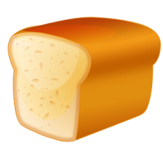________________________________
_____________________________
___________________________
____________________________

6. Write HOW MUCH or HOW MANY. Answer the questions.
a/ _________________ bananas do you eat a week?
b/ _________________ glasses of water do you drink a day?
c/ _________________ slices of bread do you eat for dinner?
d/ _________________ crisps do you eat a week?
e/ _________________ slices of pizza do you eat?
f/ _________________ chocolate do you eat a day?

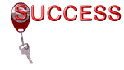
ŘEŠENÍ

1. Food and drinks
red – countable words
blue – uncountable words

James plays in American football team. Every day James has three very big meals. For breakfast he has orange juice, cereals, yoghurt, fruit, bread and butter, milk, eggs, bacon, and cake.
A typical lunch is spaghetti, fish, meat, vegetables, and apple pie with cream.
In the evening he has his main meal. Tomato soup, spaghetti, pork and beef, jacket potatoes, chicken salad, rice with mushrooms, and two or three desserts, including his favourite chocolate cake.
3. Put a/an or some.
a/ For this recipe you need some rice, an egg, some butter.
b/ I need some paper and a pen.
c/ I´ve won some money in the lottery.
d/ I´m making pizza, so I need some cheese and some ham.
e/ You´ll need a toothbrush, some toothpaste and some shampoo.
4. Write SOME or ANY.
a/ Jane hasn´t got any money.
b/ She needs some new shoes.
c/ Have we got any food for the party?
d/ I bought some presents.
e/ Do you want anything to eat?

5. Write A FEW or A LITTLE.
For this recipe you need a few onions, a little meat, a few potatoes, a few tomatoes, a few beans, a little oil and a little salt and pepper.

6. Write what is in the picture.
a/ two bottles of milk
b/ a loaf of bread
c/ three glasses of juice
d/ a bar of chocolate
e/ two cups of tea

6. Write HOW MUCH or HOW MANY. Answer the questions.
a/ How many bananas do you eat a week?
b/ How many glasses of water do you drink a day?
c/ How many slices of bread do you eat for dinner?
d/ How much crisps do you eat a week?
e/ How many slices of pizza do you eat?
f/ How much chocolate do you eat a day?

Nečíslovaný obrazový materiál je použit z galerie obrázků a klipartů Microsoft Office.

