Základní škola Olomouc

příspěvková organizace

Mozartova 48, 779 00 Olomouc

tel.: 585 427 142, 775 116 442; fax: 585 422 713

e-mail: kundrum@centrum.cz; www.zs-mozartova.cz

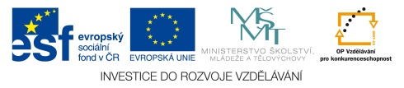

Projekt: ŠKOLA RADOSTI, ŠKOLA KVALITY
Registrační číslo projektu: CZ.1.07/1.4.00/21.3688

EU PENÍZE ŠKOLÁM
Operační program Vzdělávání pro konkurenceschopnost

Autor: | Mgr. Petra Doskočilová
Vzdělávací oblast: | Jazyk a jazyková komunikace
Vzdělávací obor: | Anglický jazyk
Vzdělávací předmět: | Anglický jazyk
Ročník: | 6.
Tematická oblast: | Gramatické jevy
Téma hodiny: | Grammar revision 3
Označení DUM: | VY_32_INOVACE_24.14.DOS.AJ.6
Vytvořeno: | 12. 03. 2014

Grammar revision- past simple


1. Complete the letter with the correct verbs. Use the past tense.
Hi Patrick
I´m on holiday in France. I ___________ yesterday evening. I ________ up early in the morning and after the breakfast I ___________ home. My dad __________ me by car. At the airport I _________ in my bag, but my pasport ___________ there. I __________ to cry. Then my mother _________ the passport in my pocket. I __________ happy and ___________ the plane.
Best wishes
Peter

find be/not catch take look arrive be start get leave

2. Make the questions.
1. ________________________________ He lived in New York.
2. ________________________________ I asked my brother.
3. ________________________________ They came at nine o´clock.
4. ________________________________ I bought new jeans.
5. ________________________________ No, I didn´t see Martin.
6. ________________________________ Yes, I did. I had pizza.
7. ________________________________ I got up at half past six.

3. Look at Monica´s diary. Write what she did or didn´t do.
●●●
Things to do!
- pack the suitcase
- take the rubbish out
- wash up
- cook the dinner at the weekend
- do the shopping
- visit grandmother
- do homework
●●●

- She packed the suitcase.
- ______________________________________________________
- ______________________________________________________
- ______________________________________________________
- ______________________________________________________
- ______________________________________________________
- ______________________________________________________

4. A detective story.
Yesterday a man died. But who was he? Write down everything you know about the man.
Work with the partner, talk about the man.
Use the verbs in the past simple.(Some verbs you may use more than ones).
drive have marry eat play like be pay work go watch listen
do ride read


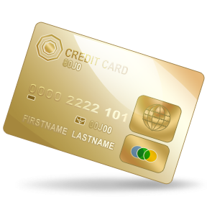


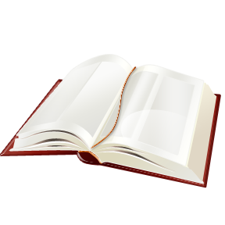

ŘEŠENÍ

Hi Patrick
I´m on holiday in France. I arrived yesterday evening. I got up early in the morning and after the breakfast I left home. My dad took me by car. At the airport I looked in my bag, but my pasport wasn´t there. I started to cry. Then my mother found the passport in my pocket. I was happy and caught the plane.
Best wishes
Peter

2. the questions.
1. Where did he live? He lived in New York.
2. Who did you ask? I asked my brother.
3. When did they come? They came at nine o´clock.
4. What did you buy? I bought new jeans.
5. Did you see Martin? No, I didn´t see Martin.
6. Did you eat? Yes, I did. I had pizza.
7. What time did you get up? I got up at half past six.

3.
She took the rubbish out.
She washed up.
She didn´t cook the dinner at the weekend.
She did the shopping.
She visited her grandmother.
She didn´t do her homework.

4. A detective story.
Tvrzení (věty) se mohou lišit. Každé dítě může pochopit obrázek svým způsobem. Úkolem je si procvičit minulý čas prostý. Cvičení lze použít hlavně pro rozvoj komunikativních dovedností. Děti se mohou do případu vnořit, jeden být detektivem, druhý svědkem apod.
Možnosti odpovědí dle nabízených klíčových slov a obrázků:
He had/drove a car.
He had a dog.
He liked pizza. He drank coffee. He liked some juice, bacon and eggs for breakfast.
He was married.
He played the piano/football/computer games.
He visited the theatre.
He watched TV. He listened to music.
He lived in a house. He had a family.
He was ill. He took pills.
He worked in the hospital. He was a doctor.
He was rich. He had a gold paycard.
He read books.
He rode a bike.

HUTCHINSON, T. Project 2 – třetí vydání. Oxford : OUP, 2008. ISBN 978-0-19-476415-5. s. 34 - 40.

Nečíslovaný obrazový materiál je použit z galerie obrázků a klipartů Microsoft Office.

